# Introduction:

This mobile interface for monitoring Web spraying programs will

* enter data,
* generate reports and view information quickly, or
* monitoring the development of the insect, the
* Opening message tracking,
* monitoring spray ,
* display tracking spatial blocks open with their priorities, and
* sprays made monitoring of insect development

Three parts of SOPFIM.

1 - [Development Tracking Application]

2 - [Message opening Application].

3 - [Spray tracking Application].

* Tracking Records: Suivi les releves

Consists:

Suivie de Development (Tracking Development)

Suivie des ouvertures de bloc (block opening)

# Development Tool

We will build a tool call [Development monitoring tool] to track the development of the insect.

the tool consists of

1 - input form for [Development data entry] form

2 - the input form will enter the data into a table [Development table]

3 - will generate report [Development report]

The information in this application will define:

1 - the [Block opening date] of [//Message Opening]

2 - The theme will show the points and blocks of stage of insect: Visual results of the [sample plots]

3 - the [block]s to be processed and specification of the development.

Add Pe: Add Sample-Place (Pe): enter on the map or by coordinates

Form to enter development data for Pe

Report for Development tracking

# Message Opening Application

The tool will track the [block opening] with the priority of traitment.

The application consists of :

1 - Form to enter the data [Form entry for message opening]

2 - the data will be entered into [Messge tracking table]

3 - the program will show the records and operations and [Message Opening],

4 - generate [Message Opening report] which is done once a day before 14 hours

Shows:

* show Pe (Sample Plot)
* Open Blocks,
* Block priorities.
* effected treatments,
* Spraying performed.
* Flight lines
* Prescriptions.

## Message Opening Report

The report will shows:

1 - [Sample plot]

2 - [block]

3 - [Spray report]

4 - Treatment performed

5 - Operations and Statements

Message Entry Form

1 - opening blocks

2 - Their priorities

3 - Spraying

4 - Sample plots

5 - Flight lines

6 - requirements

# Operation / Spray

The tool will show the block opening for spray and their priority

The "Directorare of operation" update the spray data after the PM session and morning session AM.

Usually, the data entry is made 10 Hours AM by the operation Manager

1. Data entry form for spraying
2. Table for spraying
3. Report for spraying that shows the visual layer with operations and statements

# Visual Map Interface

Visual interface for the records (releves)

The map representing the

* Block opening
* their treatment priority
* actual treatment

The thematic will be according to "Spray Width" (la largeur)

We use the 30m thematic, even we use the 100m

Correspondence will be when the operation manager has complated the Spray Report.

Geoprocessing can be done in the background to coorespendence between the lines

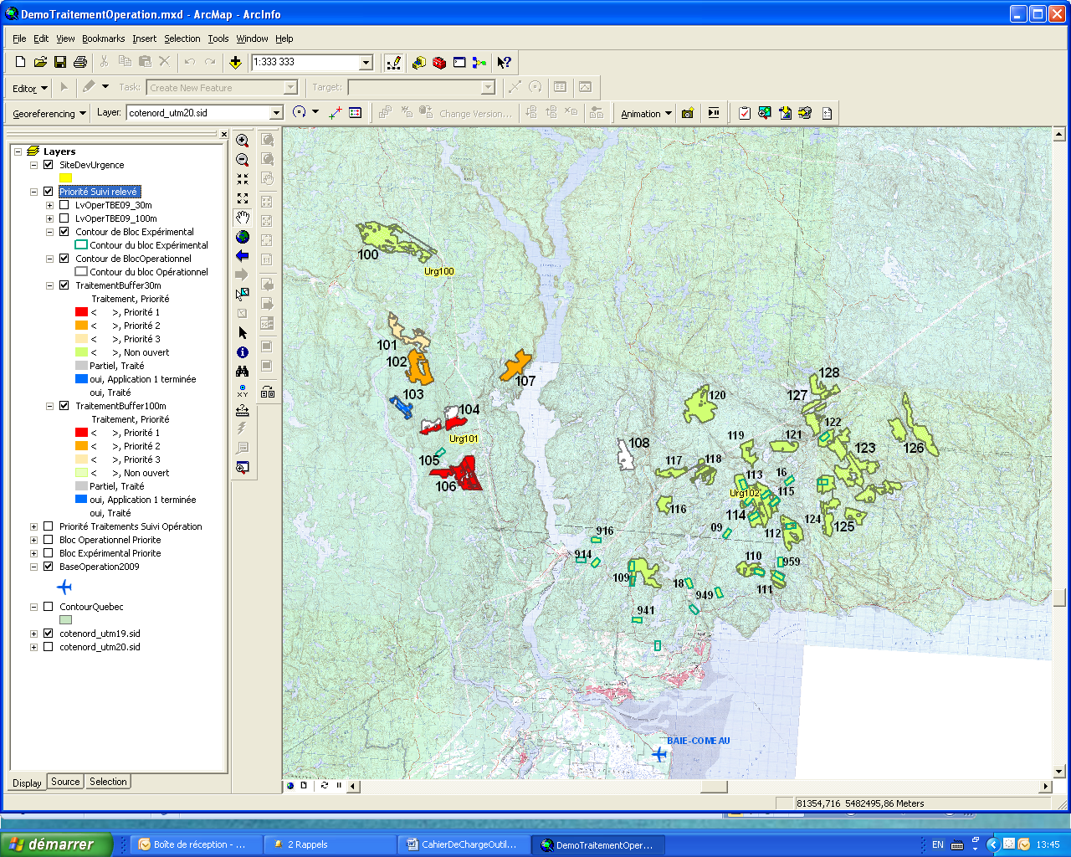

Example of line width of 30 m flight. Shows the progress of sprays per flight line.

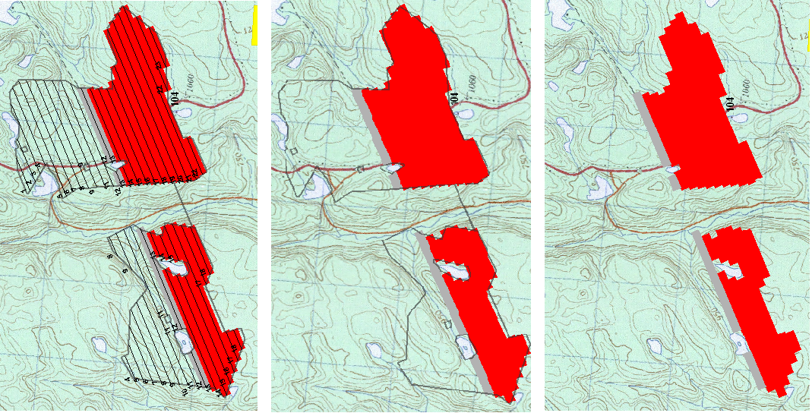

**Visual interface for operations:**

Map showing the processing priorities and treatments carried out: the outline of the block has been activated, it can be disabled needs.

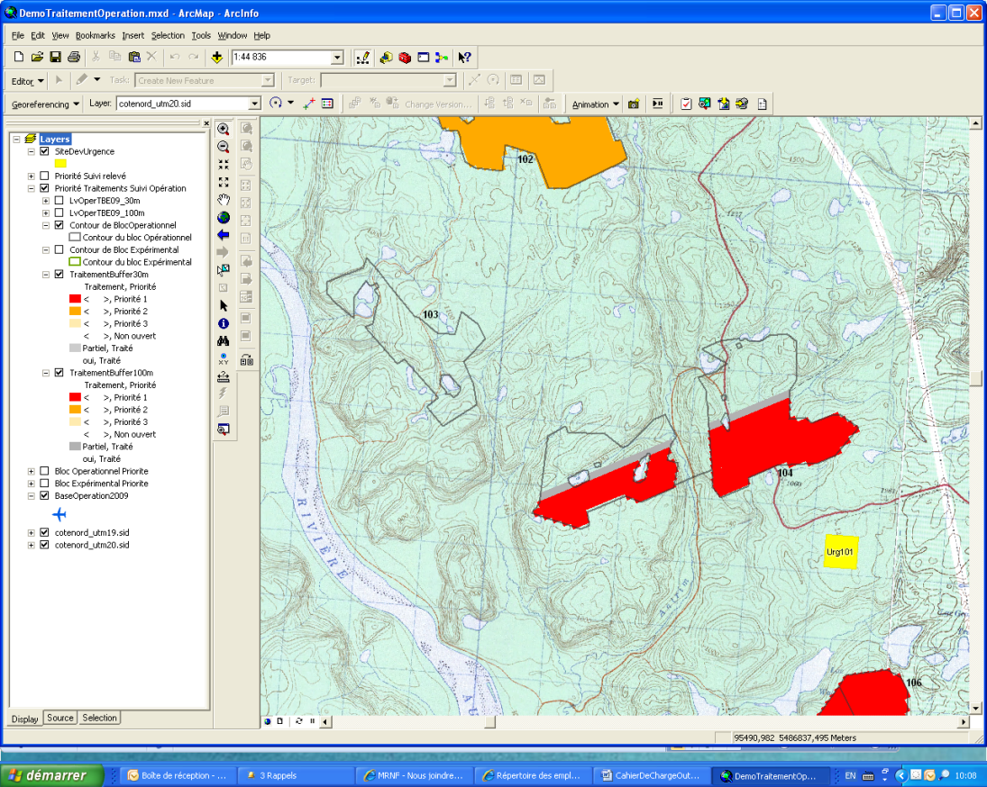

Block 104, an application, treated part

Block 104, block party, not treated as a priority 1

Block 104, line partially treated

Block 103 Treaty, supplemented

Block 102, priority 2

# Tracking Messages Application

Modifying Opening blocks will be done once a day before 14 hours.

The message notifies the operator of spray operation of block opening and their processing priority

The message of end day of spraying (PM) , or next morning (AM)

there is possibility to have two session of spraying

The record Manager will

1. Open the application, with default to the last message
2. Create a new message by copying the old one and add one to the message number
3. edit the changes needed

When relate the Record with Operations, (Message with Spray), then the operator will open the application and see the last message with the operation and treatment performed.

## Enter new Message

....

Edit Message

The Message can be edited only when it is not saved to the server.

otherwise it becomes a new message. The message will have the same date, but bear a different number if the message is edited in one day.

Fields:

Base Operation

Message Date (current date)

Block Type

Block Number

**IDI Timing:** This is the index of insect development in the block where the spraying will take place. Sprays prescribed 2 applications are made at the third instar and those prescribed pursuant to a fourth stage. Entering via a drop down setting in the system before: 3, 4 and the ability to enter manually.

**Product:** List of products that will be applied during the season. Entering via a drop down setting in the system before.

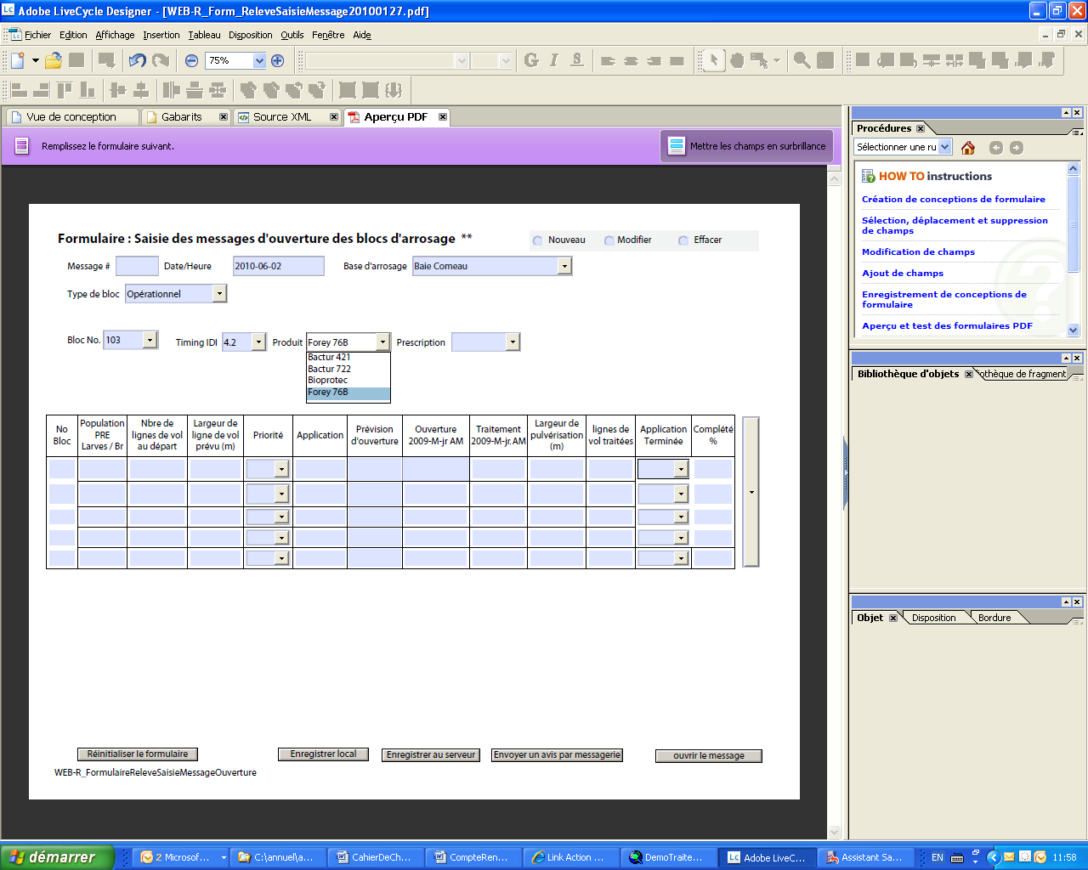

**LarvesBr:** Larves Population. Comes from the Monitoring the development table. Corresponds to the sampling results of the branches. The result is an average made from several sample plots for the same block on the same date.

**Prescription:** Number of applications that can be applied on a block to be processed. Entering via a drop down setting in the system before. Can be up to three applications on the same block. Allow the possibility of 0 x 30, this indicates that the prescription has been canceled.

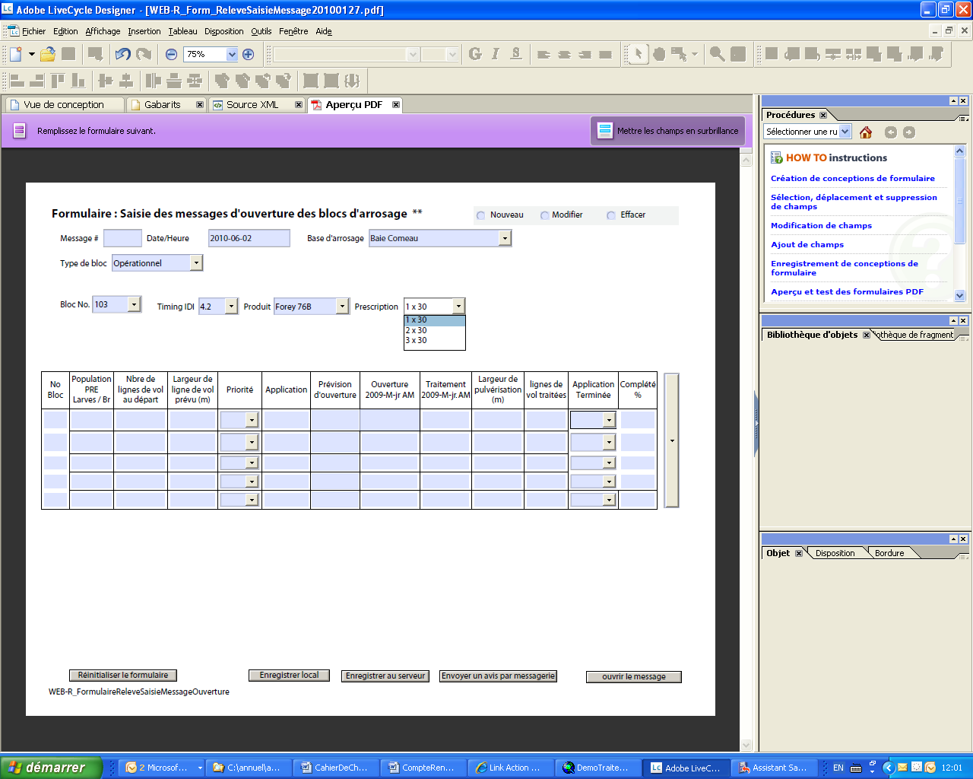

**IntervaleApp**: Number of days established between two applications, the default is empty and can choose between 1 and 10, entered via a drop down setting in the system before and the ability to enter manually. This field will automatically update the date of opening of the second or third application by adding the date of processing operations by entering the number of days required between the two applications.

**Priority:** The block is open, there is not necessarily a priority. If there is a processing priority that is defined by the number of larvae per branch and the importance of defoliation damage in this block, this is additional information which makes it a priority block versus an open frame with no priority mentioned. Priority during the program evolves. Entering via a drop down setting in the system before.

The values ​​in this field to establish priorities for a block:

Empty = Default Priority field is empty

1 = High Priority

2 = Medium Priority

3 = Low Priority

0 = No priority, the application of this block has been canceled.

5 = 1 Application is complete, but it is waiting for application 2

6 = 2 Application is complete, but it is waiting for the application 3

9 = The block is completed for the season.

When there is a complete application and it is waiting for another application, the opening date will be set according to certain criteria 5, 7 or 10 days apart. These criteria are defined when the official statements made treatment requirements.

**Application:** Choose the application: 0, 1, 2 or 3

If the block had no application, the entry for the first application will be active. If an application is made, then the application will be active and 2 that if 1 and 2 applications are made, then it will be the three that will be active. The 0 will be used only if the block is canceled.